ACCOUNTING - Kagera
Class 1 – 23/8/24
Assignment
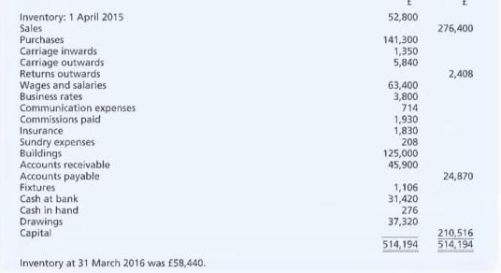
From the above question
Identify all the Non-current assets and the current assets, liabilities ( Non-current and the current) And all expenses

Class 2 – 26/8/24 (LEDGER)
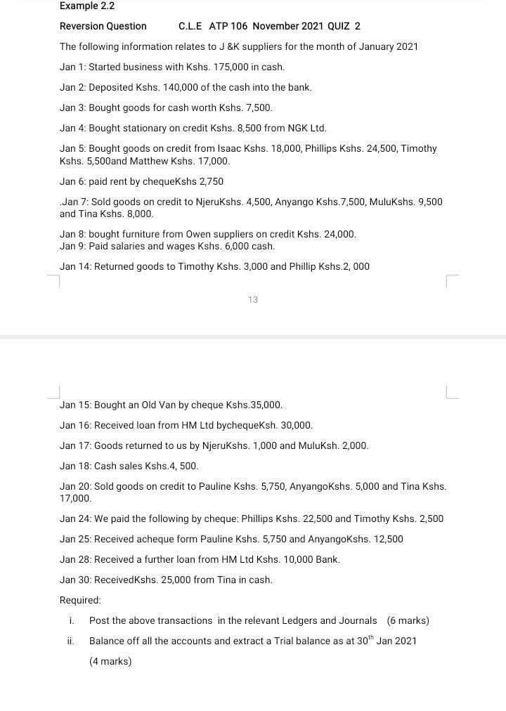
Dates to look at – Jan: 1 2 3 4 6 8 9 15 16 18

